

ASSEMBLY INSTRUCTIONS FOR LINEN DISTRIBUTION TROLLEY (LDT)

**Box Contents**

**2-3 minutes setup**

3 x shelves

2 x side frames

**1 person**

1 x top frame

1 x base

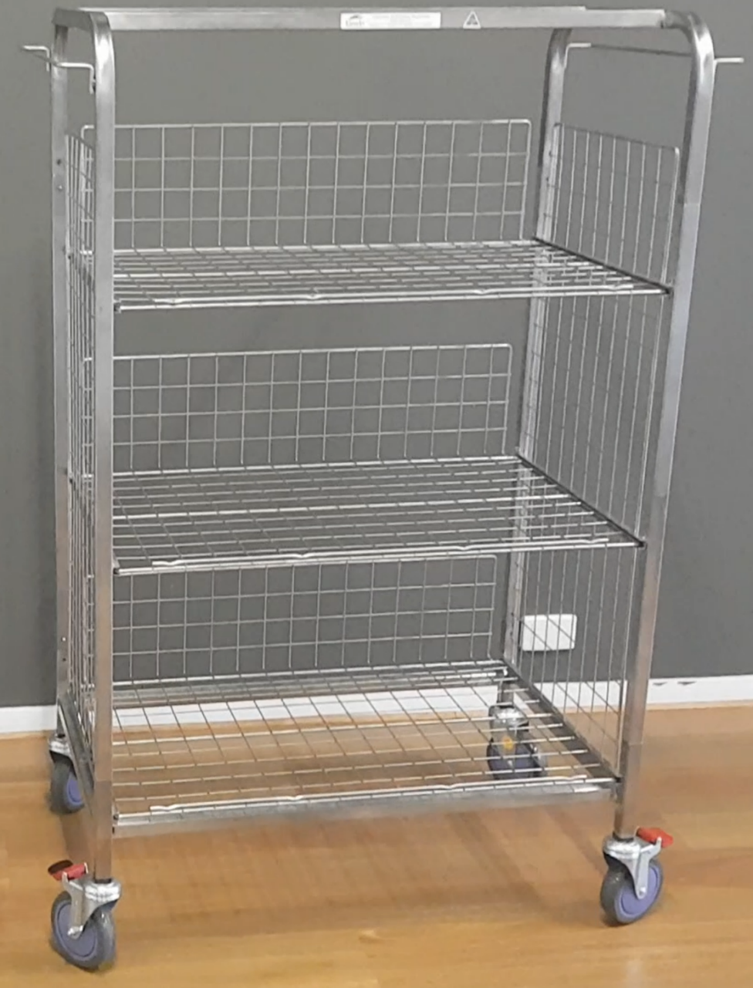

STEP 1

Remove shelves(3) from box and place aside.

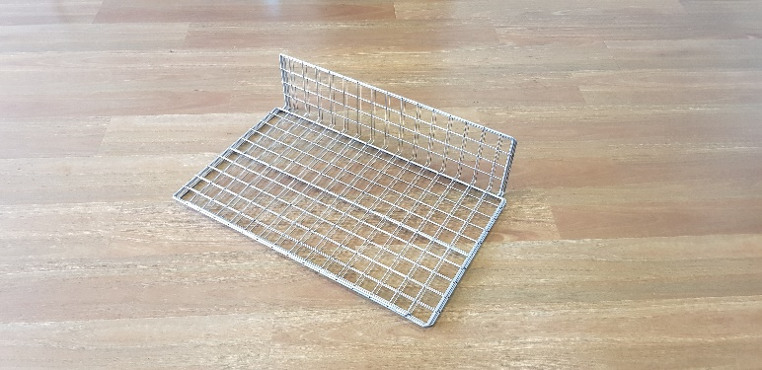

Figure Shelving for LDT Trolley

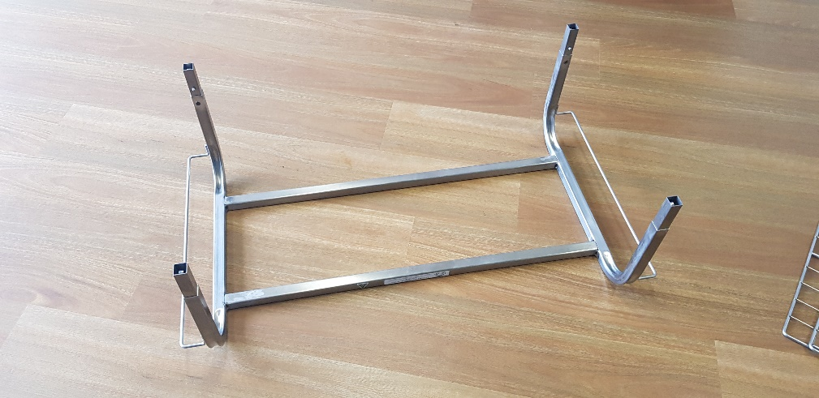

STEP 2

Remove top from box and place aside.

Figure Top frame section

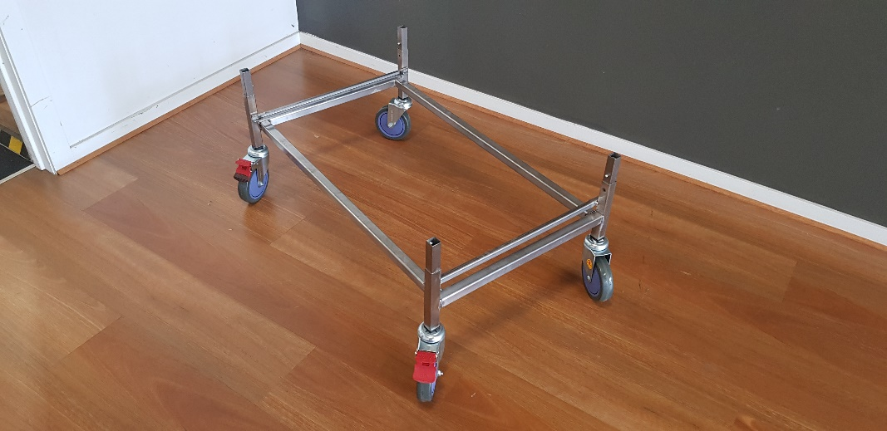

Figure Base of trolley

STEP 3

Remove base from box and place on stable surface.

*Note: Press red wheel locks into place to stop trolley from moving*

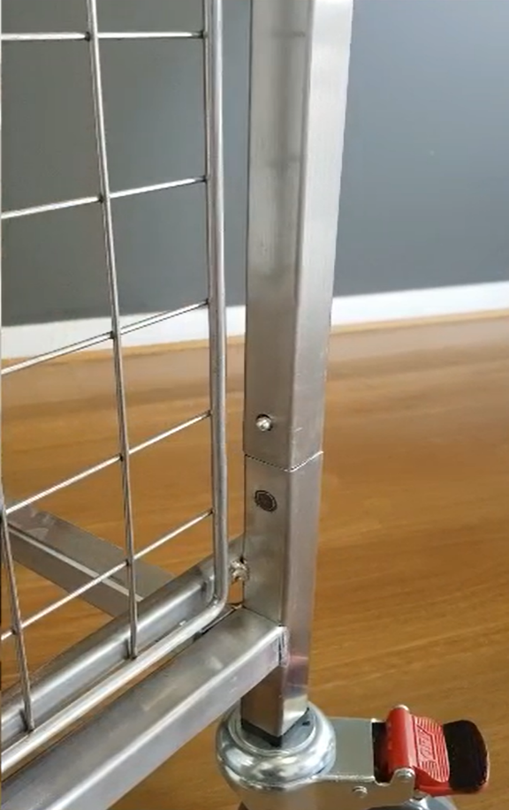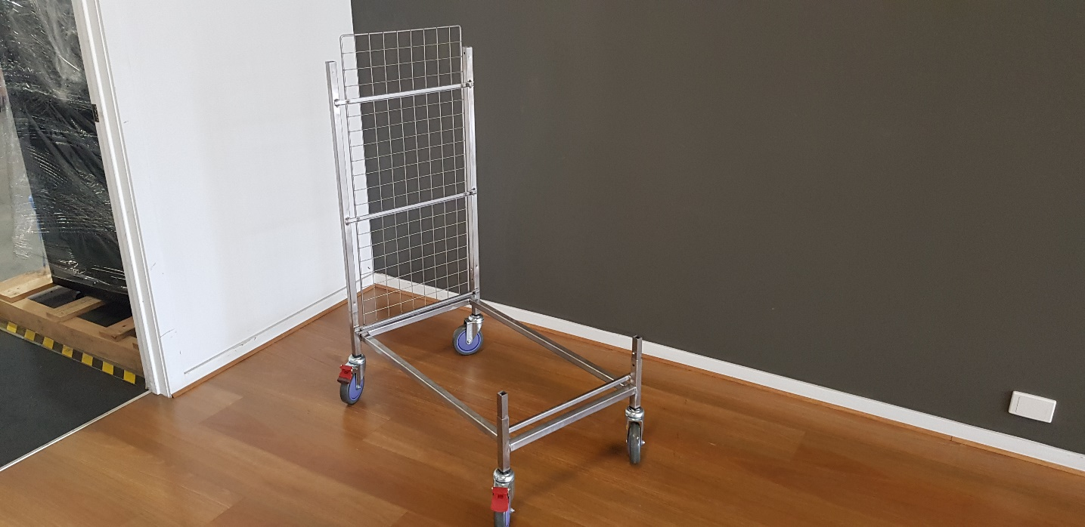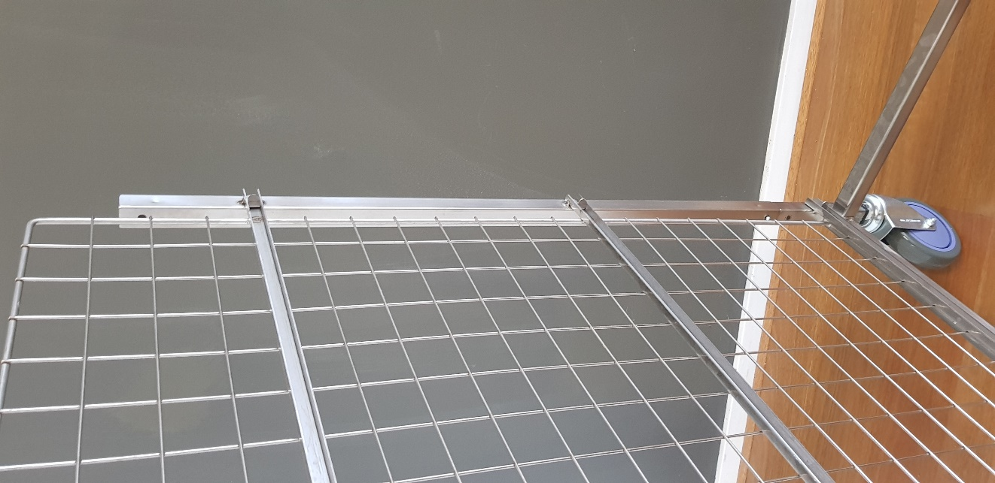



Long end

Short end



STEP 4

Attach first side frame to base keeping the horizontal bars on the inside. The short end of the frame should be facing the top (see figure 4).

Each side clicks into the corresponding frame.

The button will make a click sound when fully connected.

Figure Side frame long and short ends

Figure 5 First side frame connected

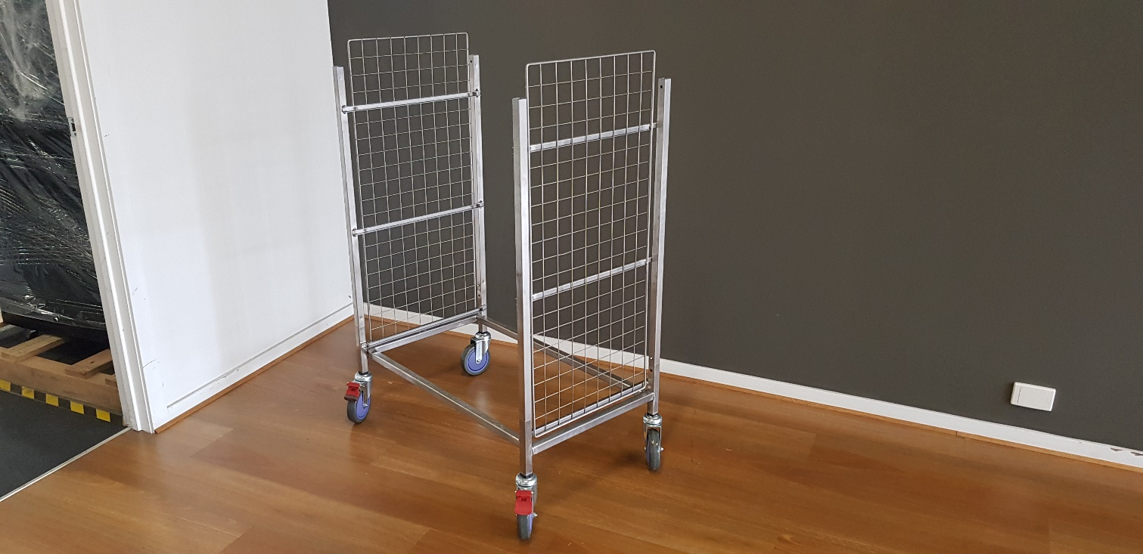

STEP 5

Attach the second side frame to the base. Once again keeping the horizontal bars facing inward and making sure the frame locks into place on both sides.

Figure 6 Second side frame connected

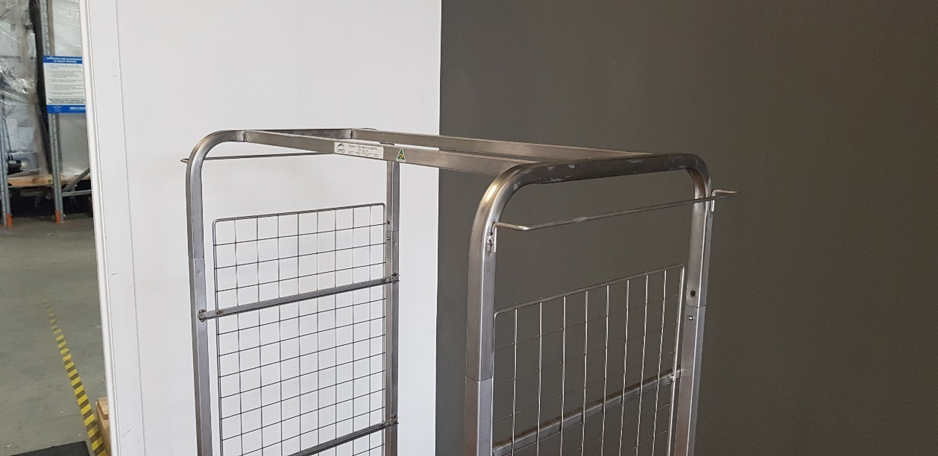

STEP 6

Attach the top frame to the side frame pieces.

Note: Having a second person will make this step easier however it can be done by one person with a little more effort.

Figure 7 top connected to side frames

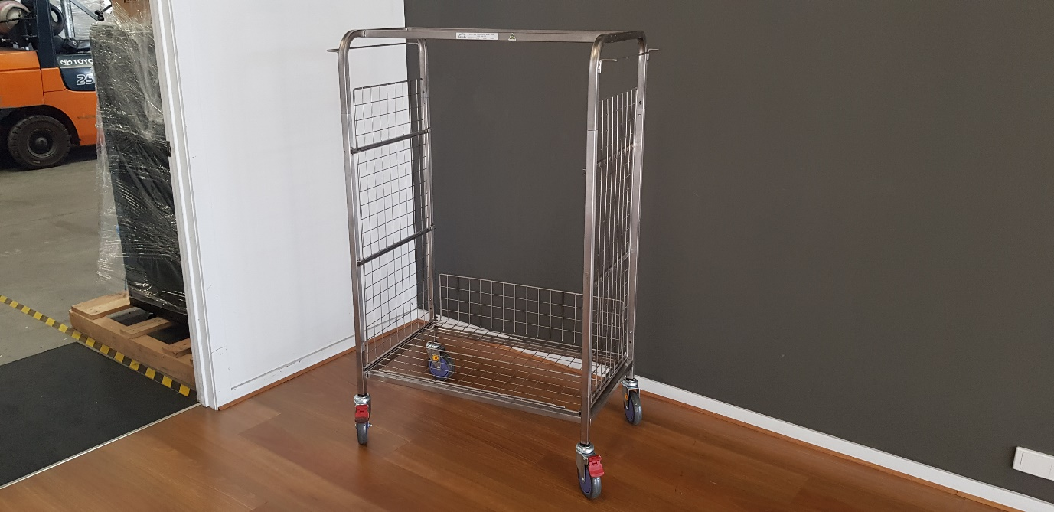

**For support with this product:**

Email: [info@laundrysolutions.com.au](mailto:info@laundrysolutions.com.au)

Phone: 1300 666 289

Web: [laundrysolutions.com.au/spec-sheets-manuals/](http://www.laundrysolutions.com.au/spec-sheets-manuals)

Figure 8 Shelf inserted into frame

Once all shelves are into the trolley frame assembly is complete.

STEP 7

With the upwards portion of the shelf facing away from you, slide each shelf into the trolley frame by placing it into the horizontal guide and pushing forward until the shelf reaches the stop.