ASSEMBLY INSTRUCTIONS FOR PERSONAL DISTRIBUTION TROLLEY (PDT)

**Box Contents**

**2-3 minutes setup**

10 x dividers

5 x baskets

**1 person**

2 x side frames

1 x top frame

1 x base

STEP 1

Remove base from box and place on stable surface.

*Note: Press red wheel locks into place to stop trolley from moving*

Figure 1 Trolley base

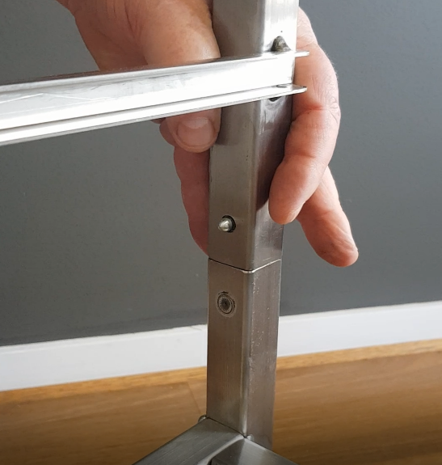

STEP 2

Attach first side frame to base keeping the horizontal bars on the inside. Each side clicks into the corresponding frame.

The button will make a click sound when fully connected.

Figure 2 First side frame attached to base

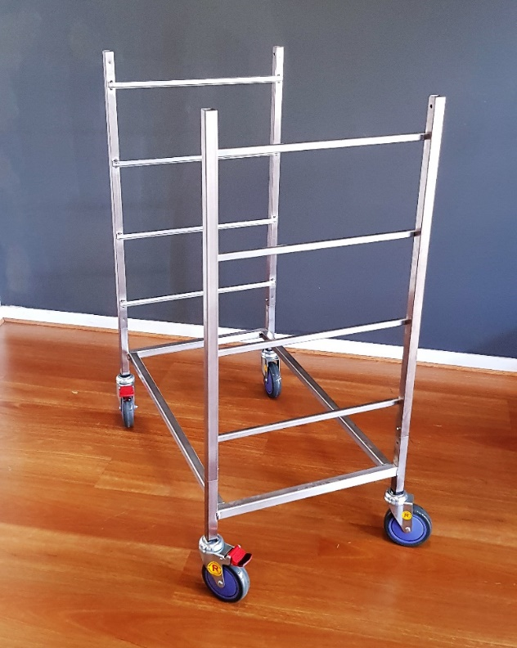

STEP 3

Attach the second side frame to the base. Once again keeping the horizontal bars facing inward and making sure the frame locks into place on both sides.

Figure 3 Second side frame attached to base

STEP 4

Remove the baskets and dividers from the box and set aside.

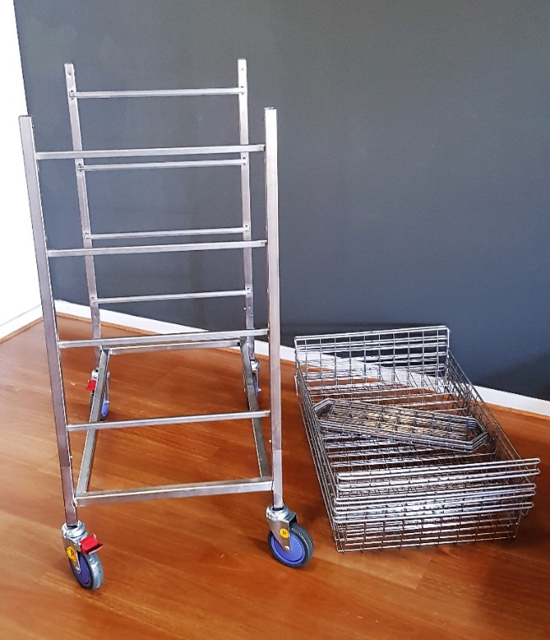

Figure 4 Baskets and dividers placed near frame

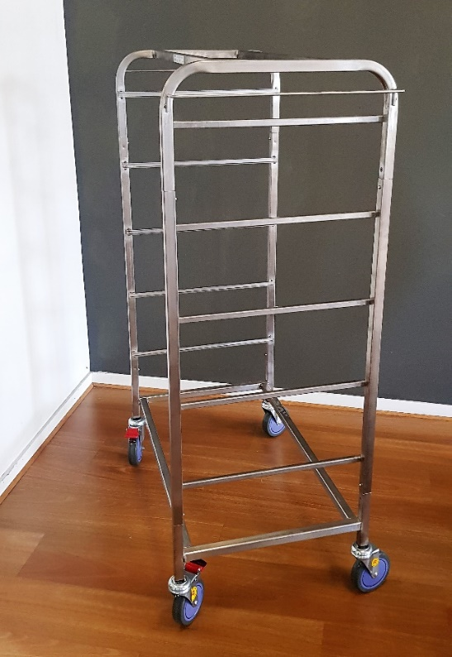

STEP 5

Attach the top frame to the side frame pieces.

Note: Having a second person will make this step easier however it can be done by one person with a little more effort.

Figure 5 Top connected to sides

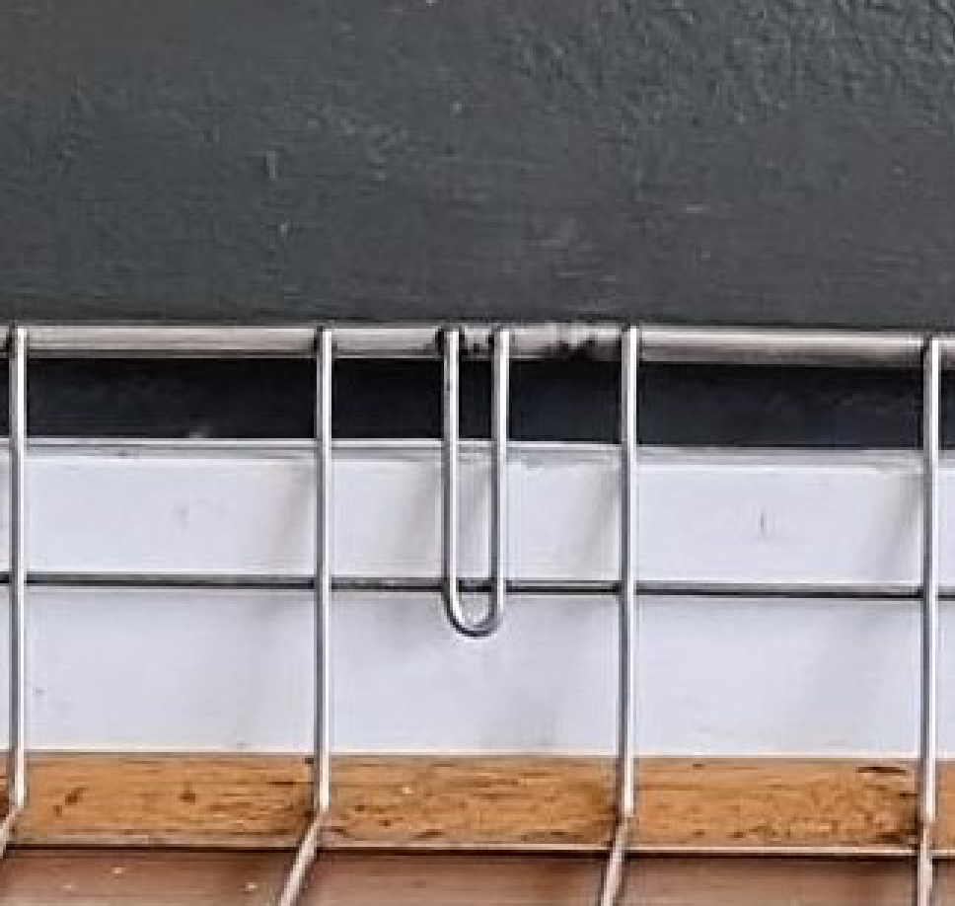

STEP 6

Insert two (2) dividers into the first basket with the edges of each divider sliding firmly into the grooves on each side of the basket.

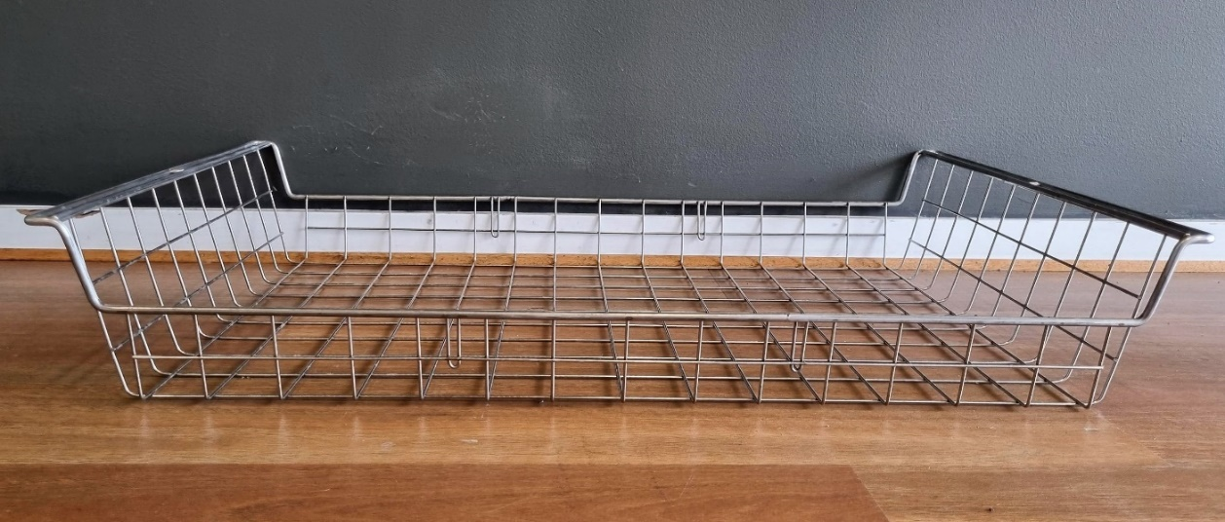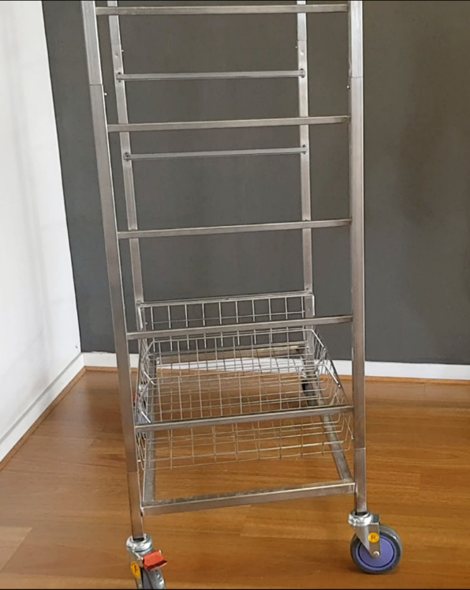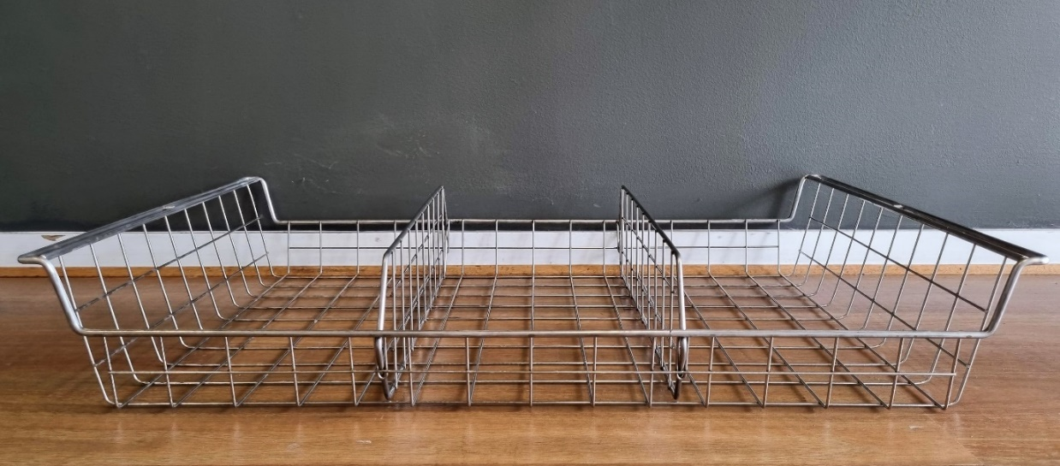

1

Figure Basket without dividers

2

**For support with this product:**

Email: [info@laundrysolutions.com.au](mailto:info@laundrysolutions.com.au)

Phone: 1300 666 289

Web: [laundrysolutions.com.au/spec-sheets-manuals/](http://www.laundrysolutions.com.au/spec-sheets-manuals)

STEP 8

Repeat steps 6 and 7 for the remaining 4 baskets.

Once all baskets have been inserted into the trolley frame assembly is complete.

Figure 8 First section in trolley

STEP 7

Insert the basket with dividers into the first section of the trolley frame.

All the baskets will universally fit into each section of the trolley frame.

Figure Basket with dividers